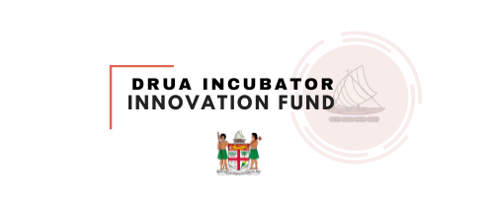
The Luxembourg-Fiji Drua Innovation Small Grants Scheme

Call For Proposals




Office of the Prime Minister
Climate Change Division

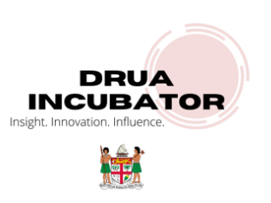


Overview: The Drua Incubator Innovation Fund

Fiji’s iconic traditional double-hulled sailing canoes, known as Na Drua, were resilient ocean-going vessels built to withstand the highly variable sailing conditions that the south-western Pacific is well known for. Similarly, the Drua Incubator (DI), a sub-unit within Fiji’s Climate Change and International Cooperation Division seeks to develop home-grown financing solutions and products to assist resilient economic development in Fiji (further detail on this sub-unit can be found in Annex 1 of this document).
The global cost of climate change adaptation has been predicted to exceed $300bn USD per annum by 2030. At the same time, globally, only 2.2% of all financing deployed in 2019 and in 2020 for climate change adaptation flowed from private sector sources to developing countries. Scaling up investment in climate adaptation is critical and to do so new innovative financial products, business types and services must be developed at the local level to help increase resilience while also improving potential to attract and access new forms of financing.
Through the Drua Incubator initiative, recent policies, and the introduction of new legislation, the Fijian Government has put in place a national framework for enabling climate adaptation actions in response to current and future projected climate change impacts and seeks to use this framework to accelerate associated activities and actions significantly in the immediate term.
To support Fiji’s efforts to scale up innovative investment in resilience building the design of a dedicated mechanism for deploying climate finance directly to the private sector and non-government actors began in early 2021. In 2022, the Drua Incubator Innovation Fund was formally established following the enactment of Fiji’s Climate Change Bill in September 2021. Fiji’s new climate change legislation sends a strong market signal to the private sector, requiring businesses and state entities to report on the activities undertaken and the considerations and investments made to address climate change risks. The Act also creates new incentives and requirements designed to prompt investment in low carbon transition and enable cross-sectoral collaboration to build resilience. In response to this legislation the Drua Incubator Innovation Fund has been designed to help support the enabling environment required to help diversify and transition Fiji’s private sector and improve the resilience of Fiji’s economy to new and emerging risks and disruptions. To do so, the Drua Incubator Innovation Fund seeks to deploy funds based on technical merit to innovative entrepreneurs and emerging business leaders. This fund, based within the Office of the Prime Minister’s, Climate Change Division, is well positioned to target the private sector and has been developed in partnership with the Government of Luxembourg and the United Nations Development Fund.
The first call for proposals under the Drua Incubator Innovation Fund was made possible through the support of UNDP and was launched in June 2022 in the form of the ‘Blue Accelerator Grant Scheme’ (Building Back Blue - Blue Accelerator Grant Scheme | United Nations Development Programme (undp.org). In April 2023 the second call for proposals will be launched through a new window supported by the Government of Luxembourg titled ‘The Luxembourg-Fiji Drua Innovation Small Grants Scheme’. Details of this new call for proposals are detailed below. These small grant schemes issued under the Drua Incubator Innovation Fund are indicative of an ongoing effort to drive new sources of financing into private and non-government organisations and businesses to support market transition and innovation.

Drua Incubator Innovation Fund
Call for Proposal/Concept Papers

FUNDING WINDOW TITLE AND DETAIL:
The Luxembourg-Fiji Drua Innovation Small Grants Scheme

Issuance Date: 27th April 2023
Type of Solicitation: Grant Funding Proposals
Closing Date and Time: 29 May 2023, 5pm Fiji Time Zone
Submit Questions to: k.pratap@finance.com.fj or vineil.narayan@undp.org
Submit applications to: druainnovationfundfj@gmail.com
Number of Awards Anticipated: Up to 13 – Subject to funding allocations
Maximum Grant Amount: Up to 75,000 FJD
Fund Manager: Climate Change Division, Office of the Prime Minister
Implementation Support: United Nations Development Programme (Innovation Challenge Modality)
Primary Donor: The Government of Luxembourg

Funding Window Objective
The ‘Drua Innovation Small Grants Scheme’ seeks to support inclusive and resilient economic development in Fiji through the financing of activities that support the private sector and align with the sustainable financing objectives defined by Fiji’s Climate Change Act and National Climate Change Policy 2018-2030. Activities in scope for support should demonstrate innovative approaches to a) scaling up / leveraging private capital for business activities that help to build socio-economic resilience to climate change, b) seed funding for the diversification of existing companies or services that have potential to support the enabling environment.

Overview of this opportunity
To support national efforts to deliver the vision set out by the Climate Change Act the Fijian Government has developed the ‘Drua Incubator Innovation Fund’. This fund will deploy grants to the public via specific calls for proposals and targeted grant schemes with different thematic focuses.
The Luxembourg-Fiji Drua Innovation Small Grants Scheme offers small grants of up to 75,000FJD to support private sector and civil society organisations to contribute directly to the market diversification, resilience building, and the internal business reform required to green our economy and minimise our exposure to climate change risks.
Grants will be provided based on specific performance indicators and the merit of proposals received. This scheme will target proposals that demonstrate strong potential to be scaled up and deliver tangible socio-economic and environmental benefits.
1. Purpose
This initiative, made possible through funding provided by the Government of Luxembourg and the Fijian Government, is a means to disburse climate financing to non-government actors and challenge them to be part of the solutions, innovation, market transformation, and business unusual needed to build resilience to climate and disaster risks. Through a focus on non-government actors – and the private sector specifically – this grant window targets initiatives that show strong potential to contribute to supporting the livelihoods and transitioning of Fiji’s economy towards a low carbon, climate resilient, and socially inclusive growth trajectory.
This dynamic grant is expected to be utilized by private sector or civil society actors for a variety of interventions and activities. Grants proposals will be accepted in relation to a broad range of intervention areas described in section 2 and assessed based on the satisfaction of the key criteria and indicators provided in section 3.
While these priority intervention areas and indicators will be central to the assessment of the merit of proposals, this grant scheme will consider a diverse range of financing needs associated with the activities needed to influence and enhance resilience-building objectives. For example, grant proceeds might be used to:
- Enable a company that has performed the same services or product production processes for decades to have access to the additional research and development funding they need to explore ways to diversify and modernize their business in order to better respond to risks posed by the climate emergency.
- Enable business and not-for-profit entities to hire GIS expertise to help map landscapes and seascapes in their vicinity with a view to assessing and managing climate change risks and opportunities.
- Enable a civil society organisation, in partnership with and leveraging the technical expertise of a private sector firm, to collaborate with a vulnerable community to improve their water security in response to changing rainfall patterns.
- Help provide the co-financing required to leverage additional private sector investment needed to support the uptake of new technologies that are instrumental in supporting business-level mitigation or adaptation strategies.
- Help provide the co-financing for business activities and technology uptake needed to accelerate actions needed to support and protect the livelihoods, health, safety and security of women and girls.
- Help to fund the research needed to support the development of innovative business diversification plans or provide the startup capital needed to support young entrepreneurs to develop new business ideas.
- Support existing company’s or groupings of companies to capitalise on the opportunities set out by the Climate Change Act, including the provisions that relate to voluntary emissions reporting.
- Support activities that demonstrate potential to prompt a ‘Green recovery’ in response to the ongoing impacts of COVID-19.
2. Areas of Intervention
Climate change related risks have exacerbated existing socio-economic challenges in Fiji and these challenges have been further impacted by COVID-19 and ongoing global market volatility. This has created complexity when it comes to navigating short-term financial priorities and balancing them with longer-term investments and goals. As a result, Drua Incubator Innovation Fund through this second call for proposals is seeking to provide opportunities to bridge investment and development-related financing gaps through the provision of small grants.
This round of innovation grants will seek to help diversify existing business operations or seed fund startup stage initiatives designed to increase compliance with Fiji’s climate change objectives. Organizations, businesses, or partnerships that are seeking to develop a concept, product, business model, or service that demonstrates strong potential to support social, environmental, or economic resilience building in Fiji and that can demonstrate alignment with the Climate Change Act is encouraged to apply.
Two cross-cutting themes should be considered and integrated into proposals that address the intervention areas identified in the next section:
A - Addressing gender inequality issues at risk of exacerbation by climate change
Proposals must align with the gender equity principles of the Climate Change Act. Proposals that deliver tangible benefits to women’s livelihoods through engagement with women’s collectives, support to women in business, scale up of empowerment and income generation diversification initiatives, and other activities that seek to support involvement of women in private sector-led climate risk management will be prioritized.
B – Minimizing and Addressing Loss and Damage
Proposals must demonstrate awareness and consideration of current and future climate change impacts and risks and offer solutions that help to support adaptation and resilience-building or that directly address climate change-driven loss and damage that has effected or is effecting a particular business, community, or sector.
While a broad range of intervention areas will be considered, priority will be placed on proposals which consider the above thematic areas while also targeting one or more of the following target intervention areas:
- Information technology and risk communication
Activities that seek to utilize data and technology to support the flow of resources, information and services to key sectors in ways that contribute to building resilience to climate change and disaster risks.
- Business risk management and diversification
Activities that help support existing businesses to adjust, alter, or diversify their existing operations and/ or enhance their risk management strategies to build resilience to climate change impacts.
- Capacity development and workforce transition
Activities that are targeted at improving technical capacity, integrating new expertise and/or empowering /employees to learn new skills and specializations in ways that support Fiji’s climate resilient development and workforce transition objectives.
- Water security, coastal protection, and flood risk management
Activities that specifically target solutions that address way in which climate change is disrupting hydro-metrological patterns and driving water security and flood related risks.
- Environmental protection and biodiversity risk management
Activities that demonstrate potential to support environmental protection and biodiversity conservation through changes to business operations, new technology, introduction of new management practices, or community engagement schemes.
3. Selection Criteria
Proposals will be vetted against the following selection criteria. Each criterion will be scored and assessed independently when the proposal is assessed. In supporting the Fiji Government to implement this initiative, UNDP will be using its Innovation Challenge modality.
A: PROPOSAL ALIGNMENT
- Policy Alignment
The proposal should demonstrate the way in which proposed activities and interventions will contribute to relevant national policies and plans. Each proposal should demonstrate awareness of relevant principles of the Climate Change Act 2021 and/or the National Climate Change Policy 2018-2030. Initiatives that demonstrate credible alignment with Objective 7.3 of the National Climate Change Policy which is entitled ‘To create a climate-ready work force and promote social entrepreneurship’ are welcomed as well as proposals that make specific reference to activities designed to leverage opportunities or readiness for requirements associated with the Climate Change Act. Additional attention to projects that demonstrate scalable activities which align with specific objectives within national plans such as the National Development Plan and National Adaptation Plan will also be considered.
- Problem Statement and Needs Assessment
Each proposal must clarify the problem or challenge it seeks to overcome and clarify the reason why progress to address the challenge in question is dependent on receiving the grant and the specific ways in which grant funding will be spent. Proposals should make reference to the way in which the activity is responsive to changing needs within the private sector and how activities will help existing programmes or businesses to improve their service delivery and resilience.
- Complementarity with Drua Incubator Principles
Proposals should seek to align with one or more of the Drua Incubator’s core principles and demonstrate the way which this principle is evident in the objective and method of the proposal. A summation of key elements of the core principles of the Drua Incubator is provided below:
- Leaving no one behind - this principle reflects the need to focus on projects and initiatives which benefit the most vulnerable in society and create inclusive solutions. The Drua Incubator is purposed to identify financial products and initiatives that can be used to scale up protection from the multi-faceted social, environmental, and economic threats posed by climate and disaster risks.

- Improving cohesion and multistakeholder collaboration– this principle relates to the need to effectively navigate a complex stakeholder landscape and to reduce fragmentation of effort. The Drua Incubator seeks to improve cooperation and coordination in an effort to rationalize the range of actors that must be involved to help reduce climate and disaster risks. Projects and activities that support collaboration between a diverse range of stakeholders to establish an inclusive approach to risk management are of particular relevance to this principle and its associated objectives.

- Increasing Risk Literacy (Foresight, Awareness, and Prevention) – this principle is focused on the development of new standards, practices, methods, and solutions designed to identify and assess current and future risks that Fiji as a whole, its communities, and private sector face. The Drua Incubator seeks to support activities that help establish long-term and sustainable approaches to risk management in part through supporting initiatives that increase local capacity to pre-empt risks and make appropriate decisions. Risk literacy can be scaled up through approaches that help stakeholders to develop foresight and establish their own ‘home-grown’ risk mitigation strategies.

In addition, proposals should incorporate outcomes that align where relevant with the pillars of the Luxembourg Sustainable Finance Strategy. This strategy articulates Luxembourg’s vision for supporting sustainable financing initiatives emphasizing:

1) the importance of awareness and promotion as a means for increasing literacy with sustainable financing concepts,
2) the requirement to actively work to unlock potential through knowledge sharing and engagement, and
3) the importance of demonstrating ability to measure progress against sustainability targets.

The strategy can be found via the following this link.

B: IMPACT AND SCALABILITY
- Collaboration and Inclusion
Proposals should demonstrate the way collaboration, inclusivity, and partnerships will be used in a strategic, formal, or informal way to help ensure benefits of the grant are shared and contribute to broader social protection and or social inclusion. Specific attention will be paid to the inclusion of indicators or outcomes that support gender equity, inclusion, and social equality.
- Theory of Change
The proposal should provide a theory of change that helps to explain the way in which the activities will create positive impact. This information should demonstrate the strategies that will be used to ensure the small grant can leverage results that are scalable and sustainable beyond the lifespan of the project.
- Measurable Results
The proposal should set out indicators and measurable targets that can be assessed and used to evaluate the project. The method for evaluating these indicators should be clarified and included within the proposed workplan.

C: CAPACITY AND MANAGEMENT
- Project Management
The Proposal should explain how the project will be managed and the way in which funds will be deployed. Information on the key individuals and their capacity to implement the activities proposed should be included.
- Financing and Budget
The proposal should explain the way in which the investments made through the grant funding will interact with and/or leverage other existing investments, operational budgets, or co-financing arrangements. The proposal should provide a clear indicative budget to ensure the assessment team can understand how funds will be used and the types of activities they will support.
- Risk Management
Proposals must include an assessment of potential unintended negative impact or outcomes that could occur as a result of the proposed intervention. This assessment should take into account social, environmental, and economic risks. Where risks are identified the proposal must illustrate the mitigation measures that will be put in place to limit and prevent unintended negative impacts resulting from any activities directly or indirectly funded via the grant scheme.
4. Eligibility criteria, grant size, implementation timeline
- Eligibility Criteria
Track 1: Grant funding up to $75,000 FJD
- Must be a locally owned business, non-government organization, or registered community-based organization.
- Minimum of 2-year operating history.
- Minimum age of the applicant must be 18 years old (Fiji citizens only).
- Women in business are encouraged to apply.
- Companies that apply must be prepared to demonstrate their compliance with relevant business operational and tax-related requirements.

Track 2: Seed funding up to $50,000 FJD
- Un-registered businesses or individuals can apply for seed funding under track 2.
- Must provide significant rationale to demonstrate the way in which the grant will seed fund the establishment and formalization of a proven business concept or initiative. The proposal should have high impact potential and strong alignment with the key criteria required and described in section 3.
- Minimum age of the applicant must be 18 years old (Fiji citizens only).
- The application must include two (2) character references for the individual or individual(s) involved.
- If the proposed business or initiative focuses on supporting a key demographic, existing business type, or specific stakeholder group a letter of support should be secured from the key stakeholder(s).

- Grant Size
- This grant program will offer small grants of up to 75,000FJD.
- Seed funding of up to 50,000FJD is available for proposals with strong demonstration of impact potential and early proof of concept.

- Implementation Timeline
- Funds must be utilized within 8 months of the receipt.
- Monitoring and Reporting
- The recipient of the grant scheme will be required to provide a final report on the use of funds which should provide measurable detail on performance against the indicators set out in the proposal.
- Applicants must be prepared to support monitoring and evaluation exercises carried out by the Climate Change Division and its implementation partner – the United Nations Development Programme (UNDP) - through the provision of required data and documentation as required.

5. How to apply?
Interested candidates can need to complete the Funding Proposal Template and the Budget Template linked below. Once completed, both templates can be submitted to druainnovationfundfj@gmail.com.
Note: It is compulsory to provide the completed submission form.
All unsuccessful candidates will be notified via email.
Funding Proposal Template | Budget Template
 | 

6. Proposal Review Process and Oversight
6.1 The Drua Incubator Innovation Fund will follow a five-step application process procedure. These processes will allow the Grant Selection Committee (GSC) to successfully select innovative and transformative proposals. The GSC will comprise of representatives from the Drua Incubator/Climate Change Division, UNDP and other experts engaged in this process. Attention will be paid to ensure there is diverse representation on the committee. Organizations submitting unsuccessful funding proposals will be notified by email.

Oversight and Review
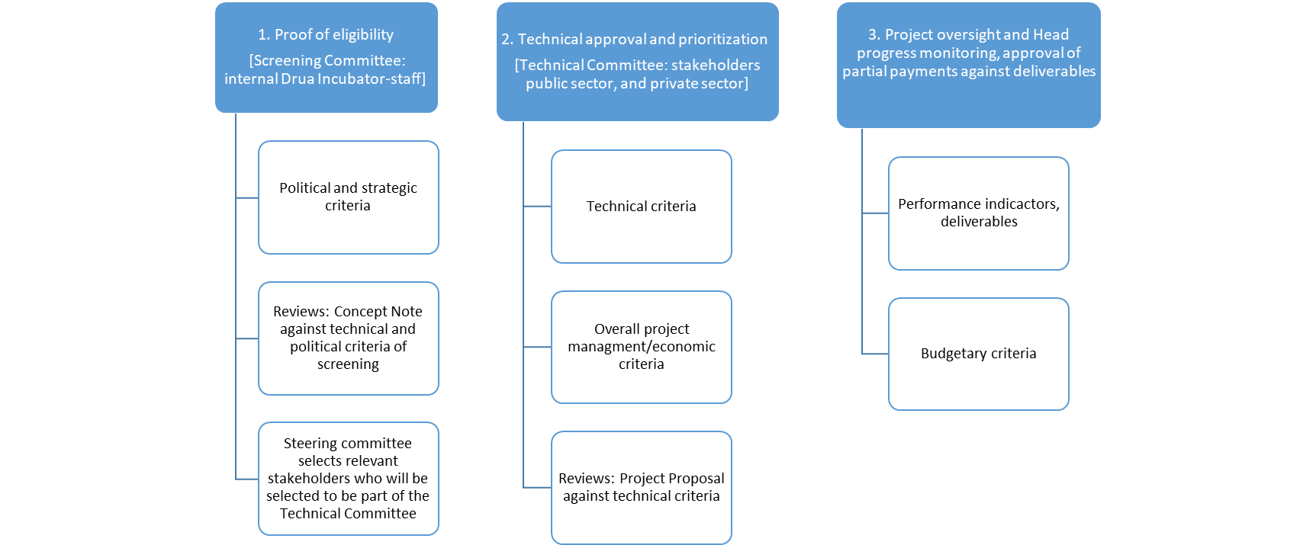
Note: Successful applications will be prioritised based on overall merit (scores) of the project concepts. If the total cost of awards for successful applications exceeds the overall budgeted amount, GSC will award small grants according to the total score for each application, starting with the highest scored application, until the available budget has been fully committed. However, if there will still be a number of eligible applications for which small grants cannot be awarded due to the insufficient funds available, these non-funded applications will, upon the consent of the GSC, be placed on a reserve list, in descending order of their scores. In the cases where applications awarded small grants have subsequently been withdrawn or found non-compliant, applications will be replaced from the reserve list in order of their respective scores for funding.

6.2 Deadline for applications is 29 May 2023 5:00pm Fiji Time. Applications after the deadline will not be considered. Below please find the schedule and timelines for the application process.
Schedule | Timelines | Revised Timelines*
Call for Proposals Open | 27 April 2023 | 27 April 2023
Online information session | 3rd and 10 May 2023 | 7 and 9 June 2023
Deadline for applications | 29 May 2023 | 16 June 2023
Screening of all proposals and shortlisting | 29 – 2 June 2023 | 19 June – 17 July 2023
Shortlisted projects invited to discuss their proposals | 5 – 7 June 2023 | 20 July – 7 August 2023
Final Assessment by Grant Selection Committee | 12 – 13 June 2023 | 21 – 23 August 2023
Grant Disbursement | 14 – 21 June 2023 | 28 August - 7 September 2023
Implementation begins | July 2023 – February 2024 (8 months) | September 2023 – May 2024 (8 months)
*This column has been added to provide revised timelines
6.3 Proposals will be selected based the following criteria relative to section 3 above:
 | Selection Criteria | Score
CONCEPT ALIGNMENT
1 | Policy Alignment | Max. 10 points
2 | Problem Statement and Needs Assessment | Max 10 points
3 | Complementarity with Drua Incubator Principles | Max. 10 points
IMPACT AND SCALABILITY
4 | Collaboration and Inclusion | Max 10 points
5 | Theory of Change | Max 15 points
6 | Measurable Results | Max 15 points
CAPACITY AND MANAGEMENT
7 | Project Management | Max. 10 points
8 | Financing and Budget | Max. 10 points
9 | Risk Management | Max. 10 points
TOTAL |  | 100 Points

7. Guidance on Application Submission.
Specific questions and requests for clarification concerning this call for proposals can be directed to:
Mr. Krishan Pratap
Drua Incubator Partnership and Project Coordinator
Climate Change Division
| Email: k.pratap@finance.com.fj

OR

Mr. Vineil Narayan
UNDP Project Manager – Blue Economy
UNDP Pacific Multi-Country Office in Fiji
| Email: vineil.narayan@undp.org

Annex: About the Drua Incubator?
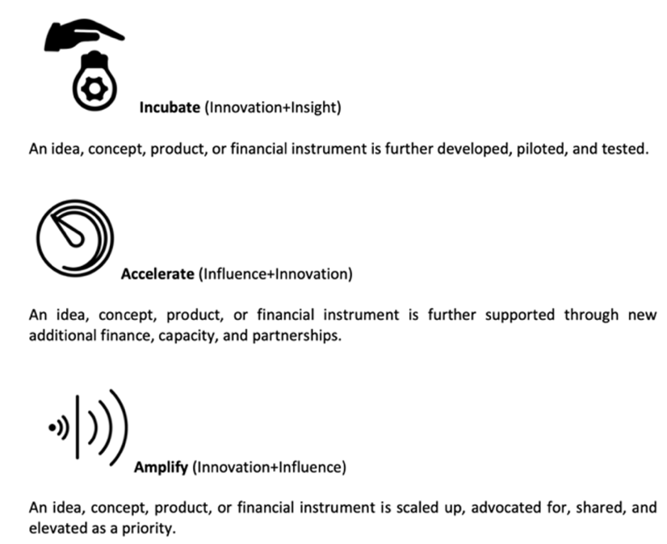
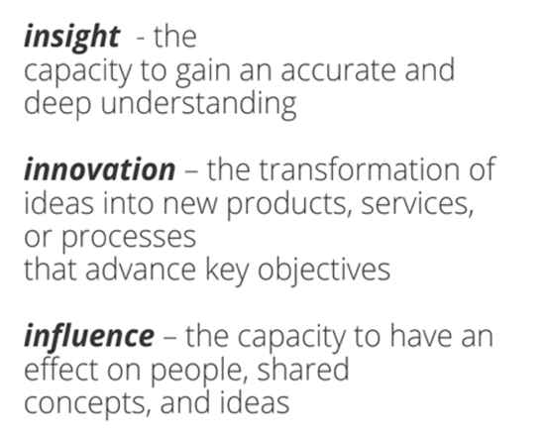
The Drua Incubator (DI) concept was born out of the recognition of the need for dynamic partnerships with concessional financiers, donor agencies, and the private sector to help develop financing initiatives that are specifically tailored to the unique requirements of Pacific governments, citizens, communities, and businesses. To serve this purpose the Drua Incubator was established as a sub-unit of the Climate Change Division through a Cabinet decision and via the financial support provided by the Government of Luxembourg. The DI seeks to create instruments, home-grown financing solutions and products to assist resilient economic development and serve to improve and protect the quality of life of Pacific Islanders in the face of climate change. To do so the Drua Incubator has focused on promoting three capabilities: insight, innovation, and influence. These capabilities have been used to drive an approach which focuses on incubating, accelerating, and amplifying ideas, concepts, and products with high potential for impact.
The Drua Incubator collaborates with a range of partners including but not limited to the World Resources Institute, United Nations Development Program, United Nations Capital Development Fund, Pollination Group, The Global NDC Partnership, the Carbon Market Institute, and the Pacific Islands Forum Secretariat. Our partnerships have been developed around a distinct partnership strategy and informed by the support of our key donors.
The Drua Incubator is overseen by the Climate Change Division and reports to the Prime Minister / Minister Climate Change. The Drua Incubator Implementation Board – comprised of government and non-government stakeholders as well as key donors supports the design of the Drua Incubator workplan and associated investment strategies.
